RISC style CPU16 with Custom ISA:
ISA:
Opcode (hex) | Mnemonic | Effect
0x0 | NOP | EAT 5*
0x1 | MOV | R[rd]<- {8’b0,imm8}
0x2 | ADD | R[rd] ← R[rs1] + R[rs2}
0x3 | SUB | R[rd] ← R[rs1] - R[rs2]
0x4 | AND | R[rd] ← R[rs1] & R[rs2]
0x5 | OR | R[rd] ← R[rs1] \| R[rs2]
0x6 | XOR | R[rd] ← R[rs1] ^ R[rs2]
0x7 | MUL | R[rd] ← R[rs1] * R[rs2]
0x8 | MAC | R[1] ← R[1] + (R[rs1] * R[rs2])
0x9 | NN | R[rd] ← (R[rs1]·ws + R[rs2]·w2 + bias)[15:0]
0Xa | MATMUL | R[rd] ← matmul_part ( c00)
0xb | MOV | R[rd] ← R[rs1]
0xc | OUT | trace output
0Xd | NOT | ~INPUT
0xf | STOP | $finish

DEMO PROGRAMS:
First program
LOADI R1, 10
LOADI R2, 5
ADD R3, R1, R2
SUB R4, R2, R4
AND R5, R2, R4
OR R6, R2, R4
XOR R7, R3, R2
MUL R5, R2, R4
SIMD R3, R2, R4
MAC R4, R2, R4
NN R1
MATMUL R0
STOP

Full coverage test case
1001 // LOADI R0 1
1102 // LOADI R1 2
1203 // LOADI R2 3
1704 // LOADI R7 4

2301 // ADD R3 R0 R1
4412 // AND R4 R1 R2
5512 // OR R5 R1 R2
6612 // XOR R6 R1 R2
7712 // MUL R7 R1 R2

9012 // NN R0 (uses R1, R2, R7)
A145 // MATMUL R1 (uses R0–R7 for A, B matrices)
B65 // MOV R6 R5
E000 // OUT R0
E110 // OUT R1
F000 // STOP
All mod covered
LOADI R0 1 // ALU base: R0 = 1
LOADI R1 2 // R1 = 2
LOADI R2 3 // R2 = 3
LOADI R3 4 // R3 = 4

ADD R4 R0 R1 // ALU ADD: 1+2 = 3
SUB R5 R2 R1 // ALU SUB: 3–2 = 1
AND R6 R2 R3 // ALU AND: 3 & 4
OR R7 R2 R3 // ALU OR: 3 | 4
XOR R0 R2 R3 // ALU XOR: 3 ^ 4
MUL R1 R2 R3 // ALU MUL: 3 × 4 = 12

MAC R2 R4 R5 // MAC: R2 ← R2 + R4×R5 (core MAC module)
MAC2 R3 R6 R7 // MAC2: R3 ← R3 + R6×R7 (second MAC path, if you kept 0xC as MAC2)
MOV R4 R1 // MOV: R4 ← R1

NN R0 // NN: R0 ← NN(x1=R1, x2=R2, b=R7)
// effectively uses MAC‑like sums (x1·w1 + x2·w2 + b)
MATMUL R5 // MATMUL: R5 ← c00 (A×B)
// where A = [R0,R1; R2,R3], B = [R4,R5; R6,R7]
OUT R0 // output R0 (NN result)
OUT R1 // output R1
OUT R2 // output R2 (MAC result)
OUT R3 // output R3 (MAC2 result)
OUT R5 // output R5 (MATMUL result)
STOP

ASSEMBLER.C: MNEMONICS -> HEX
#include <stdio.h>
#include <stdlib.h>
#include <string.h>
#include <ctype.h>

int reg_num(const char *r)
{
if (r == NULL || toupper((unsigned char)r[0]) != 'R')
return -1;

int n = atoi(r + 1);
if (n < 0 || n > 7)
return -1;

return n;
}

void trim_comment(char *line)
{
for (int i = 0; line[i]; i++)
{
if (line[i] == ';' || line[i] == '#')
{
line[i] = '\0';
return;
}
}
}

int main(void)
{
FILE *fin = fopen("E:\\vhdl programs\\CPU16modular\\CPU16modular.srcs\\sim_1\\new\\input.txt", "r");
FILE *fout = fopen("E:\\vhdl programs\\CPU16modular\\CPU16modular.srcs\\sim_1\\new\\program.txt", "w");

if (!fin)
{
printf("Cannot open input.txt\n");
return 1;
}

if (!fout)
{
printf("Cannot create program.txt\n");
fclose(fin);
return 1;
}

char line[128];
int line_no = 0;

while (fgets(line, sizeof(line), fin))
{
line_no++;
trim_comment(line);

char op[20] = {0}, a[20] = {0}, b[20] = {0}, c[20] = {0};
unsigned short instr = 0;

int count = sscanf(line, "%19s %19s %19s %19s", op, a, b, c);
if (count <= 0)
continue;

for (int i = 0; op[i]; i++)
op[i] = toupper((unsigned char)op[i]);

if (strcmp(op, "NOP") == 0)
{
instr = 0x0000;
}
else if (strcmp(op, "STOP") == 0)
{
instr = 0xF000;
}
else if (strcmp(op, "LOADI") == 0)
{
int rd = reg_num(a);
int imm = atoi(b);

if (rd < 0)
{
printf("Line %d: invalid register in LOADI\n", line_no);
continue;
}

instr = (0x1 << 12) | (rd << 9) | (imm & 0xFF);
}
else if (strcmp(op, "ADD") == 0 || strcmp(op, "SUB") == 0 ||
strcmp(op, "AND") == 0 || strcmp(op, "OR") == 0 ||
strcmp(op, "XOR") == 0 || strcmp(op, "MUL") == 0 ||
strcmp(op, "MAC") == 0)
{
int rd = reg_num(a);
int rs1 = reg_num(b);
int rs2 = reg_num(c);
int opcode = 0;

if (rd < 0 || rs1 < 0 || rs2 < 0)
{
printf("Line %d: invalid register in %s\n", line_no, op);
continue;
}

if (strcmp(op, "ADD") == 0) opcode = 0x2;
else if (strcmp(op, "SUB") == 0) opcode = 0x3;
else if (strcmp(op, "AND") == 0) opcode = 0x4;
else if (strcmp(op, "OR") == 0) opcode = 0x5;
else if (strcmp(op, "XOR") == 0) opcode = 0x6;
else if (strcmp(op, "MUL") == 0) opcode = 0x7;
else if (strcmp(op, "MAC") == 0) opcode = 0x8;

instr = (opcode << 12) | (rd << 9) | (rs1 << 6) | (rs2 << 3);
}
else if (strcmp(op, "NN") == 0)
{
int rd = reg_num(a);
if (rd < 0)
{
printf("Line %d: invalid register in NN\n", line_no);
continue;
}

instr = (0x9 << 12) | (rd << 9);
}
else if (strcmp(op, "MATMUL") == 0)
{
int rd = reg_num(a);
if (rd < 0)
{
printf("Line %d: invalid register in MATMUL\n", line_no);
continue;
}

instr = (0xA << 12) | (rd << 9);
}
else if (strcmp(op, "MOV") == 0)
{
int rd = reg_num(a);
int rs1 = reg_num(b);
if (rd < 0 || rs1 < 0)
{
printf("Line %d: invalid register in MOV\n", line_no);
continue;
}
instr = (0xB << 12) | (rd << 9) | (rs1 << 6);
}
else if (strcmp(op, "MAC2") == 0)
{
int rd = reg_num(a);
int rs1 = reg_num(b);
int rs2 = reg_num(c);
if (rd < 0 || rs1 < 0 || rs2 < 0)
{
printf("Line %d: invalid register in MAC2\n", line_no);
continue;
}
instr = (0xC << 12) | (rd << 9) | (rs1 << 6) | (rs2 << 3);
}
else
{
printf("Line %d: unknown instruction %s\n", line_no, op);
continue;
}

fprintf(fout, "%04X\n", instr);
}
fclose(fin);
fclose(fout);
printf("Assembly complete -> program.txt generated\n");
return 0;
}

CPU16.V
`timescale 1ns /1 ps
module CPU16(
input clk,
input rst,
output [15:0] dbg
);

reg [15:0] pc;
wire [15:0] instr;

instr_mem IMEM(.addr(pc), .instr(instr));

wire [3:0] opcode = instr[15:12];
wire [2:0] rd = instr[11:9];
wire [2:0] rs1 = instr[8:6];
wire [2:0] rs2 = instr[5:3];

wire [7:0] imm8 = instr[7:0]; // used only for LOADI#imm

wire [15:0] rdata1, rdata2, r0,r1,r2,r3,r4,r5,r6,r7;
reg wen;
reg [2:0] waddr;
reg [15:0] wdata;

reg_file RF(
.clk(clk), .rst(rst), .wen(wen), .waddr(waddr), .wdata(wdata),
.raddr1(rs1), .raddr2(rs2), .rdata1(rdata1), .rdata2(rdata2),
.r0(r0),.r1(r1),.r2(r2),.r3(r3),.r4(r4),.r5(r5),.r6(r6),.r7(r7)
);

wire [15:0] alu_out;
wire [2:0] alu_op =
(opcode == 4'h2) ? 3'b000 : // ADD
(opcode == 4'h3) ? 3'b001 : // SUB
(opcode == 4'h4) ? 3'b010 : // AND
(opcode == 4'h5) ? 3'b011 : // OR
(opcode == 4'h6) ? 3'b100 : // XOR
(opcode == 4'h7) ? 3'b101 : // MUL
(opcode == 4'h8) ? 3'b110 : // MAC
3'b111; // reserved

ALU16 ALU(.a(rdata1), .b(rdata2), .acc(r1), .op(alu_op), .result(alu_out));

wire [31:0] nn_out;
NN NN0(.x1(rdata1), .x2(rdata2), .w1(rdata1), .w2(rdata2), .b(r7), .y(nn_out));

wire [15:0] c00,c01,c10,c11;
Mat_mul MM(
.a00(r0), .a01(r1), .a10(r2), .a11(r3),
.b00(r4), .b01(r5), .b10(r6), .b11(r7),
.c00(c00), .c01(c01), .c10(c10), .c11(c11)
);
wire [15:0] mac_out;
MAC MAC0(
.a(rdata1),
.b(rdata2),
.acc(r1),
.result(mac_out)
);
assign dbg = r1;

always @(posedge clk or posedge rst) begin
if (rst) begin
pc <= 0;
wen <= 0;
waddr <= 0;
wdata <= 0;
end else begin
wen <= 0;
pc <= pc + 2;

case(opcode)
4'h0: ; // Eat 5*

4'h1: begin // LoadI
wen <= 1;
waddr <= rd;
wdata <= {8'b0, imm8};
end

4'h2: begin // ADD
wen <= 1;
waddr <= rd;
wdata <= alu_out;
end

4'h3: begin // SUB
wen <= 1;
waddr <= rd;
wdata <= alu_out;
end

4'h4: begin // AND
wen <= 1;
waddr <= rd;
wdata <= alu_out;
end

4'h5: begin // OR
wen <= 1;
waddr <= rd;
wdata <= alu_out;
end

4'h6: begin // XOR
wen <= 1;
waddr <= rd;
wdata <= alu_out;
end

4'h7: begin // MUL
wen <= 1;
waddr <= rd;
wdata <= alu_out;
end

4'h8: begin // MAC (acc = R1)
wen <= 1;
waddr <= rd;
wdata <= alu_out;
end

4'h9: begin // NN
wen <= 1;
waddr <= rd;
wdata <= nn_out[15:0];
end

4'hA: begin // MMAT00
wen <= 1;
waddr <= rd;
wdata <= c00;
end

4'hB: begin // MOV R,R
wen <= 1;
waddr <= rd;
wdata <= rdata1;
end
// MOV rd rs1
// 4'hC: begin
// wen <= 1;
// waddr <= rd;
// wdata <= rdata1; // R[rd] ? R[rs1]
// end
4'hC: begin
wen <= 1;
waddr <= rd;
wdata <= mac_out; // R[rd] ? R[rs1]
end

4'hD: begin
wen <= 1;
waddr <= rd;
wdata <= alu_out;
end

4'hF: begin // EXIT
$display("FINAL: R0=%h R1=%h R2=%h", r0,r1,r2);
#5 $finish;
end

default: ; // NOP
endcase
end
end

endmodule

instr_mem.v
`timescale 1ns / 1ps
//////////////////////////////////////////////////////////////////////////////////
// Company:
// Engineer:
//
// Create Date: 26.04.2026 16:43:42
// Design Name:
// Module Name: instr_mem
// Project Name:
// Target Devices:
// Tool Versions:
// Description:
//
// Dependencies:
//
// Revision:
// Revision 0.01 - File Created
// Additional Comments:
//
//////////////////////////////////////////////////////////////////////////////////

module instr_mem(
input [15:0] addr,
output [15:0] instr
);
reg [15:0] mem [0:255];

// Load machine code from program.txt
/* initial begin
$readmemh(
"E:/vhdl programs/CPU16modular/CPU16modular.srcs/sim_1/new/program.txt",
mem
);
*/
integer i;

initial begin
for (i = 0; i < 256; i = i + 1)
mem[i] = 16'h0000; // default NOP

$readmemh("E:/vhdl programs/CPU16modular/CPU16modular.srcs/sim_1/new/program.txt", mem);

$display("Instruction Loaded:");
$display("mem[0] = %h", mem[0]);
$display("mem[1] = %h", mem[1]);
$display("mem[2] = %h", mem[2]);
end

// Since PC increases by 2:
// PC = 0,2,4,6...
// convert to memory index using >> 1
assign instr = mem[addr >> 1];

endmodule

reg_file.v
module reg_file(
input clk,
input rst,
input wen,
input [2:0] waddr,
input [15:0] wdata,
input [2:0] raddr1,
input [2:0] raddr2,
output reg [15:0] rdata1,
output reg [15:0] rdata2,
output [15:0] r0,r1,r2,r3,r4,r5,r6,r7 // ? Move outputs here
);

reg [15:0] regs [7:0];
integer i;

always @(posedge clk or posedge rst) begin
if (rst) begin
for (i=0; i<8; i=i+1)
regs[i] <= 16'h0;
end else if (wen) begin
regs[waddr] <= wdata;
end
end

always @(*) begin
rdata1 = regs[raddr1];
rdata2 = regs[raddr2];
end

// ? Debug outputs
assign r0 = regs[0];
assign r1 = regs[1];
assign r2 = regs[2];
assign r3 = regs[3];
assign r4 = regs[4];
assign r5 = regs[5];
assign r6 = regs[6];
assign r7 = regs[7];

endmodule

ALU16.v
`timescale 1ns / 1ps

module ALU16(
input [15:0] a, // rs1
input [15:0] b, // rs2
input [15:0] acc, // R1 (accumulator)
input [2:0] op,
output reg [15:0] result
);

always @(*) begin
case(op)
3'b000: result = a + b; // ADD
3'b001: result = a - b; // SUB
3'b010: result = a & b; // AND
3'b011: result = a | b; // OR
3'b100: result = a ^ b; // XOR
3'b101: result = a * b; // MUL

//Not of Acc till now just a
3'b110: result = ~a ;

default: result = 16'b0;
endcase
end
endmodule

NN.v(neuron)
`timescale 1ns / 1ps

module NN(
input [15:0] x1,
input [15:0] x2,
input [15:0] w1,
input [15:0] w2,
input [15:0] b,
output [31:0] y
);

assign y = (x1 * w1) + (x2 * w2) + b;

endmodule

Mat_mul.v
module Mat_mul(
input [15:0] a00,a01,a10,a11,
input [15:0] b00,b01,b10,b11,
output [15:0] c00,c01,c10,c11
);

assign c00 = (a00*b00) + (a01*b10);
assign c01 = (a00*b01) + (a01*b11);
assign c10 = (a10*b00) + (a11*b10);
assign c11 = (a10*b01) + (a11*b11);

endmodule

MAC.v
`timescale 1ns / 1ps
module MAC(
input [15:0] a,
input [15:0] b,
input [15:0] acc,
output [31:0] result
);
assign result = acc + (a * b);
endmodule

Test Bench code:
Cpu16_tb_modular.v
`timescale 1ns / 1ps
module CPU16_tb_moduler;
// Inputs
reg clk;
reg rst;

// Output
wire [15:0] dbg;

// Device Under Test

CPU16 uut (
.clk(clk),
.rst(rst),
.dbg(dbg)
);

// Clock Generation
// 10ns clock period
initial begin
clk = 0;
forever #5 clk = ~clk;
end
// Test Sequence
initial begin
clk = 0;
// Apply Reset
rst = 1;
#20;

rst = 0;

// Run simulation long enough
#1000;

$finish;
end
// Monitor Values
initial begin
$monitor(
"Time=%0t | rst=%b | dbg(R1)=%h", $time, rst, dbg);

end

endmodule

Console Output after running Simulation:
run 1000ns
Instruction Loaded:
mem[0] = 1001
mem[1] = 1202
mem[2] = 1403
Time=0 | rst=1 | dbg(R1)=0000
Time=20000 | rst=0 | dbg(R1)=0000
Time=45000 | rst=0 | dbg(R1)=0002
Time=125000 | rst=0 | dbg(R1)=000c
FINAL: R0=0069 R1=000c R2=fffc
$finish called at time : 180 ns : File "E:/vhdl programs/CPU16modular/CPU16modular.srcs/sources_1/new/CPU16.v" Line 160
INFO: [USF-XSim-96] XSim completed. Design snapshot 'CPU16_tb_moduler_behav' loaded.
INFO: [USF-XSim-97] XSim simulation ran for 1000ns
launch_simulation: Time (s): cpu = 00:00:03 ; elapsed = 00:00:07 . Memory (MB): peak = 1879.258 ; gain = 0.414

Waveform:
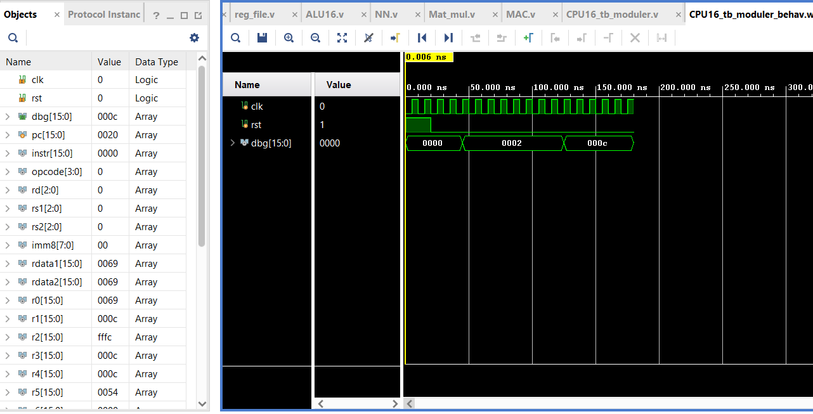
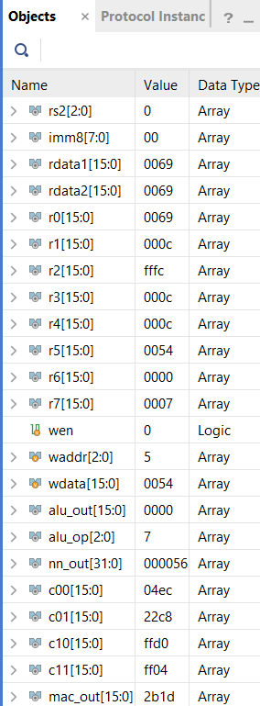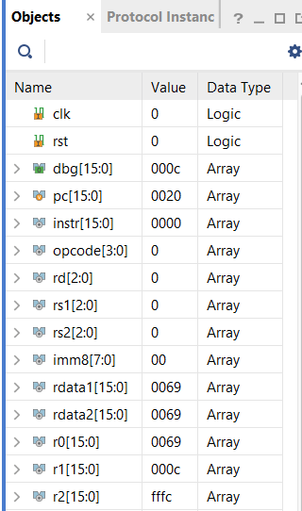bo

